SIMPLE STORAGE SERVICE

AWS offers a wide range of storage services that can be configured depending on your project requirements and use cases. AWS comes up with different types of storage services for maintaining highly confidential data, frequently accessed data, and often accessed storage data. You can choose from various storage service types such as Object Storage as a Service(Amazon S3), File Storage as a Service (Amazon EFS), Block Storage as a Service (Amazon EBS), backups, and data migration options.

USES FOR AMAZON S3:

Amazon S3 is used for various purposes in the Cloud because of its robust features with scaling and Securing of data. It helps people with all kinds of use cases from fields such as Mobile/Web applications, Big data, Machine Learning and many more. The following are a few Wide Usage of Amazon S3 service.

Data Storage: Amazon s3 acts as the best option for scaling both small and large storage applications. It helps in storing and retrieving the data-intensitive applications as per needs in ideal time.

Backup and Recovery: Many Organizations are using Amazon S3 to backup their critical data and maintain the data durability and availability for recovery needs.

Hosting Static Websites: Amazon S3 facilitates in storing HTML, CSS and other web content from Users/developers allowing them for hosting Static Websites benefiting with low-latency access and cost-effectiveness.

Data Archiving: Amazon S3 Glacier service integration helps as a cost-effective solution for long-term data storing which are less frequently accessed applications.

Big Data Analytics: Amazon S3 is often considered as data lake because of its capacity to store large amounts of both structured and unstructured data offering seamless integration with other AWS Analytics and AWS Machine Learning Services.

AMAZON S3 BUCKETS:

Amazon S3 bucket is a fundamental Storage Container feature in AWS S3 Service. It provides a secure and scalable repository for storing of Objects such as Text data,

Images, Audio and Video files over AWS Cloud. Each S3 bucket name should be named globally unique and should be configured with ACL (Access Control List).

How Does Amazon S3 works:

Amazon S3 works on organizing the data into unique S3 Buckets, customizing the buckets with Acccess controls. It allows the users to store objects inside the S3 buckets with facilitating features like versioning and life-cycle management of data storage with scaling.

The following are a few main features of Amazon s3.

- Amazon S3 Buckets and Objects

Amazon S3 Bucket: Data, in S3, is stored in containers called buckets. Each bucket will have its own set of policies and configurations. This enables users to have more control over their data. Bucket Names must be unique. Can be thought of as a parent folder of data. There is a limit of 100 buckets per AWS account. But it can be increased if requested by AWS support.

Amazon S3 Objects: Fundamental entity type stored in AWS S3.You can store as many objects as you want to store. The maximum size of an AWS S3 bucket is 5TB. It consists of the following:

Key
Version ID
Value
Metadata
Subresources
Access control information
Tags

2. Amazon S3 Versioning and Access Control

S3 Versioning: Versioning means always keeping a record of previously uploaded files in S3. Points to Versioning are not enabled by default. Once enabled, it is enabled for all objects in a bucket. Versioning keeps all the copies of your file, so, it adds cost for storing multiple copies of your data. For example, 10 copies of a file of size 1GB will have you charged for using 10GBs for S3 space. Versioning is helpful to prevent unintended overwrites and deletions. Objects with the same key can be stored in a bucket if versioning is enabled (since they have a unique version ID). To know more about versioning refer this article - Amazon S3 Versioning

Access control lists (ACLs): A document for verifying access to S3 buckets from outside your AWS account. An ACL is specific to each bucket. You can utilize S3 Object Ownership, an Amazon S3 bucket-level feature, to manage who owns the objects you upload to your bucket and to enable or disable ACLs.

3. Bucket policies and Life Cycles

Bucket Policies: A document for verifying the access to S3 buckets from within your AWS account, controls which services and users have what kind of access to your S3 bucket. Each bucket has its own Bucket Policies.

Lifecycle Rules: This is a cost-saving practice that can move your files to AWS Glacier (The AWS Data Archive Service) or to some other S3 storage class for cheaper storage of old data or completely delete the data after the specified time. To know more about refer this article - Amazon S3 Life Cycle Management

4. Keys and Null Objects

Keys: The key, in S3, is a unique identifier for an object in a bucket. For example in a bucket 'ABC' your GFG.java file is stored at javaPrograms/GFG.java then 'javaPrograms/GFG.java' is your object key for GFG.java.

Null Object: Version ID for objects in a bucket where versioning is suspended is null. Such objects may be referred to as null objects.List) and Other settings for managing data efficiently.

How To Use an Amazon S3 Bucket

Step 1: Login into the Amazon account with your credentials and search form S3 and click on the S3. Now click on the option which is "Create bucket" and configure all the options which are shown while configuring.

Step 2: After configuring the AWS bucket now upload the objects into the buckets based upon your requirement. By using the AWS console or by using AWS CLI following is the command to upload the object into the AWS S3 bucket.

aws s3 cp <local-file-path> s3://<bucket-name>/

Step 3: You can control the permissions of the objects which was uploaded into the S3 buckets and also who can access the bucket. You can make the bucket public or private by default the S3 buckets will be in private mode.

Step 4: You can manage the S3 bucket lifecycle management by transitioning. Based upon the rules that you defined S3 bucket will be transitioning into different storage classes based on the age of the object which is uploaded into the S3 bucket.

Step 5: You need to turn to enable the services to monitor and analyze S3. You need to enable the S3 access logging to record who was requesting the objects which are in the S3 buckets.

TYPES OF STORAGE CLASSES :

AWS S3 provides multiple storage types that offer different performance and features and different cost structures.

Standard: Suitable for frequently accessed data, that needs to be highly available and durable.

Standard Infrequent Access (Standard IA): This is a cheaper data-storage class and as the name suggests, this class is best suited for storing infrequently accessed data like log files or data archives. Note that there may be a per GB data retrieval fee associated with the Standard IA class.

Intelligent Tiering: This service class classifies your files automatically into frequently accessed and infrequently accessed and stores the infrequently accessed data in infrequent access storage to save costs. This is useful for unpredictable data access to an S3 bucket.

One Zone Infrequent Access (One Zone IA): All the files on your S3 have their copies stored in a minimum of 3 Availability Zones. One Zone IA stores this data in a single availability zone. It is only recommended to use this storage class for infrequently accessed, non-essential data. There may be a per GB cost for data retrieval.

Reduced Redundancy Storage (RRS): All the other S3 classes ensure the durability of 99.999999999%. RRS only ensures 99.99% durability. AWS no longer recommends RRS due to its less durability.

How to Upload and Manage Files on Amazon S3?

Amazon s3 bucket for uploading and managing the files on Amazon S3. Try to create the S3 Bucket as discussed above. Once the S3 Bucket is created, you can upload the files through various ways such as AWS SDKs, AWS CLI, and Amazon S3 Management Console. Try managing the files by organizing them into folders within the S3 Bucket and applying access controls to secure the access. Features like Versioning and Lifecycle policies provide the management of data efficiently with optimization of storage classes.

How to Access Amazon S3 Bucket?

You can work and access the Amazon S3 bucket by using any one of the following methods

- AWS Management Console

- AWS CLI Commands

- Programming Scripts

1. AWS Management Console

We can access the AWS S3 bucket using the AWS management console which is a web-based user interface. Firstly you need to create an AWS account and login to the Web console and from there you can choose the S3 bucket option from Amazon S3 service. ( AWS Console >> Amazon S3 >> S3 Buckets )

2. AWS CLI Commands

In this methods firstly you have to install the aws cli software in the terminal and try on configuring the aws account with access key, secret key and the default region. Then on taking the `aws --help` , you can figure out the s3 service usage. For example , To view try on running following command:

aws s3 ls

3. Programming scripts

Amazon S3 bucket by using a scripting programing languages like Python and with using libraries such as boto3 library you can perform the AWS S3 tasks.

AWS S3 Bucket Permissions

Bucket Policies: Bucket policies can be attached directly to the S3 bucket and they are in JSON format which can perform the bucket level operations. With the help of bucket policies, you can grant permissions to the users who can access the objects present in the bucket. If you grant permissions to any user he can download, and upload the objects to the bucket. You can create the bucket policy by using Python.

Access Control Lists (ACLs): ACLs are legacy access control mechanisms for S3 buckets instead of ACLs we are using the bucket policies to control the permissions of the S3 bucket. By using ACL you can grant the read, and access to the S3 bucket or you can make the objects public based on the requirements.

IAM Policies: IAM policies are mostly used to manage the permissions to the users and groups and resources available in the AWS by using the IAM roles options. You can attach an IAM policy to an IAM entity (user, group, or role) granting them access to specific S3 buckets and operations.

Create a S3 bucket, with no public access and upload files to the bucket & view the logs using cloudwatch for the uploaded files.

Amazon Simple Storage Service (Amazon S3) or Amazon S3 is an object type, high-speed or with minimal latency, low-cost and scalable storage service provided by AWS. S3 also allows you to store as many objects as you'd like with an individual object size limit of five terabytes. It provides 99.999999999 (11 '9's) percent durability and 99.99 percent availability of the objects which reside in it. In this article, you will create your first bucket in Amazon S3.

Step 1: Log on to your AWS Console. If you don't have an account, you can create it absolutely free as Amazon provides a 1-year free tier to its new users.

Step 2: In the search bar located at the top of your AWS Management Console, type "Amazon S3". You will see something like this:

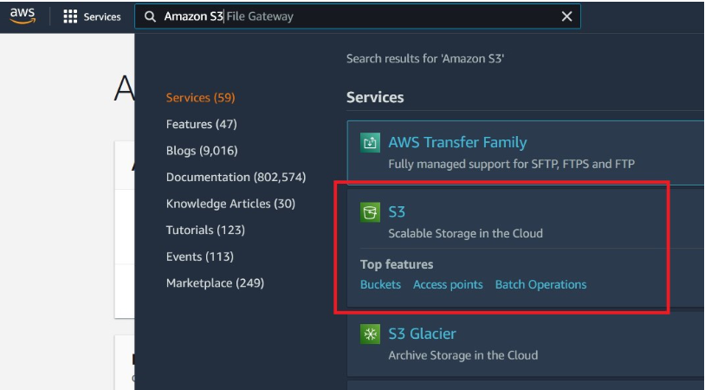

Step 3: Click on "S3 - Scalable Storage in the Cloud" and proceed further.

Step 4: Click on "Create Bucket". A new pane will open up, where you have to enter the details and configure your bucket.

Step 5: Enter the name of your bucket (We are giving geeksforgeeks-bucket in our case). The following are some rules for naming a bucket in Amazon S3:

A bucket name should be unique across all Amazon S3 buckets.

Bucket names must be between 3 and 63 characters long.

Bucket names can consist only of lowercase letters, numbers, dots (.), and hyphens (-).

You cannot write a bucket name as an IP Address like 192.168.0.1.

Bucket names must begin and end with a letter or number.

Bucket names should not contain two adjacent dots (.).

Bucket names should not end with -s3alias.

Bucket names should not start with xn--.

Step 6: Next, choose an AWS region nearest to your location or where you want your data to reside. In our case, it is [Asia Pacific (Mumbai) ap-south-1].

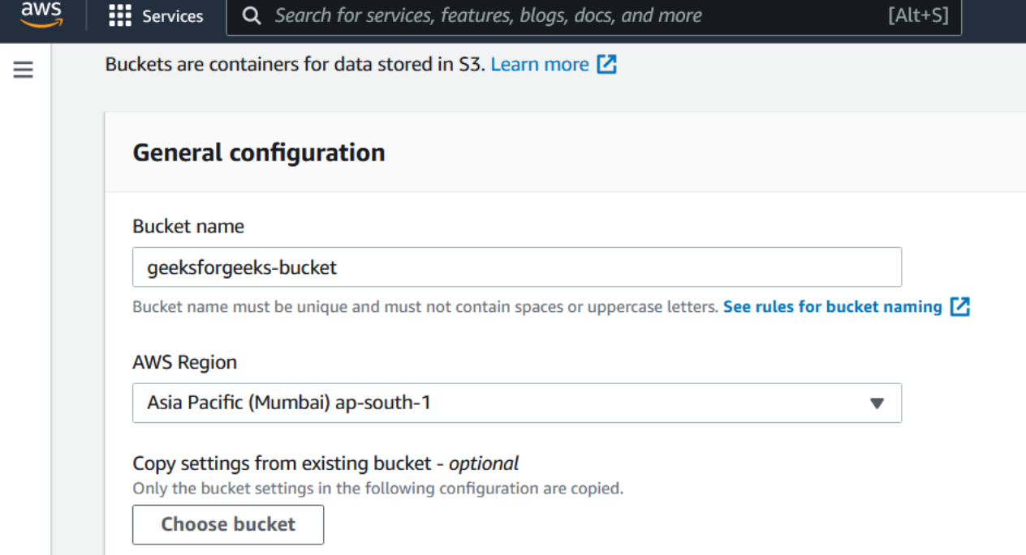

In Block Public Access settings for this bucket category, ensure that BLOCK ALL PUBLIC ACCESS has been checked. If you want to host your static website in this bucket, you can change the settings later.

In the Bucket Versioning category, choose Disabled. Bucket versioning is helpful when you want to track any changes in the file made, intentionally or unintentionally. You can see the previous versions of a file, retrieve it, restore it or preserve it.

Step 7: Click on Create Bucket.

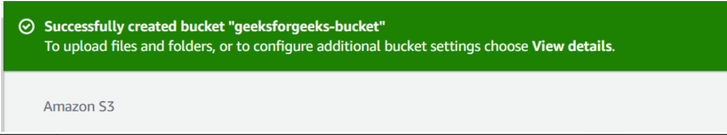

AWS Application Load Balancer

The application load balancer distributes incoming HTTP and HTTPS traffic across multiple targets such as Amazon EC2 Instances, microservices, and containers, based on request attributes. When the load balancer receives a connection request, it evaluates the Listener rules in priority order to determine which rule to apply, and if applicable, it selects the target from the target group for the rule action. AWS EC2 and Elastic Load Balancing are two different services that work well together. AWS ELB is built to support increased traffic without increasing the hourly cost. ELB scales automatically.

Types of Elastic Load balancers

The Elastic Load balancer supports in different ways, which are

- Application load balancer

- Network load balancer

- Gateway load balancer

- Classic load balancer

Components of Application Load Balancer:

The Load balancing is made up of three components:

Origin pools: These contain one or more servers.

Origin servers: These respond to individual requests.

A load balancer: This decides which traffic goes to each origin pool

If the load balancer works normally, requests to your application will go to individual servers directly. With a load balancer, requests first go through the load balancer. Your load balancer then routes requests to specific pools. Within each pool, requests then go to individual servers. And that server is what responds to the request.

How Application Load balancer work

Clients make requests to your application.

The listeners in your load balancer receive requests matching the protocol and port that you configure.

The receiving listener evaluates the incoming request against the rules you specify, and if applicable, routes the request to the appropriate target group. You can use an

HTTPS listener to offload the work of TLS encryption and decryption to your load balancer.

Healthy targets in one or more target groups receive traffic based on the load balancing algorithm, and the routing rules you specify in the listener.

Overview of Application Load Balancer

An Application Load Balancer functions at the application layer, the seventh layer of the Open Systems Interconnection (OSI) model. After the load balancer receives a request, it evaluates the listener rules in priority order to determine which rule to apply, and then selects a target from the target group for the rule action.

Elastic Load Balancing scales your load balancer as traffic to your application changes over time. Elastic Load Balancing can scale to the vast majority of workloads automatically, and configure health checks, which are used to monitor the health of the registered targets so that the load balancer can send requests only to the healthy targets.

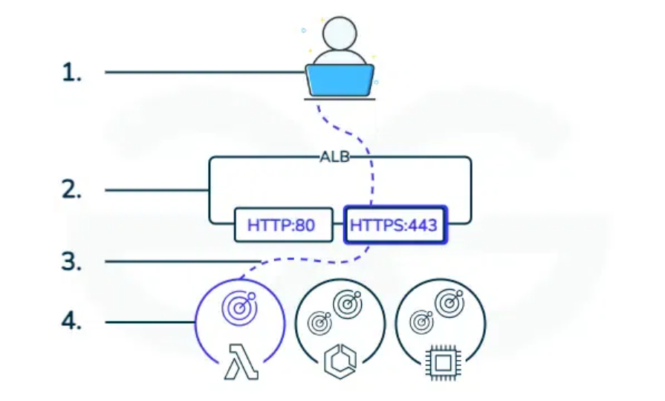

Features of Application Load Balancer

Application Load Balancer operates at the request level (layer 7), routing traffic to targets (EC2 instances, containers, IP addresses, and Lambda functions) based on the content of the request. Application Load Balancer simplifies and improves the security of your application, by ensuring that the latest SSL/TLS ciphers and protocols are used at all times.

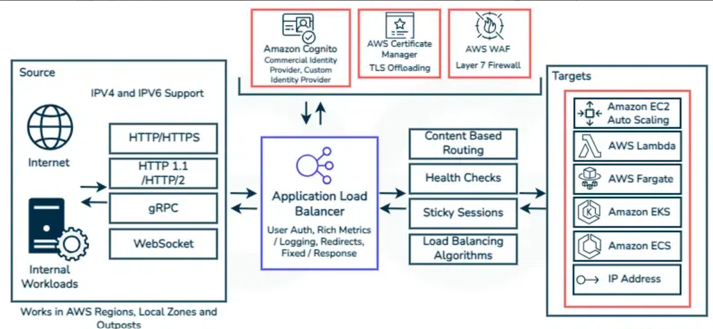

1. Native IPv6 Support

Application Load Balancers support native Internet Protocol version 6 (IPv6) in a VPC. This will allow clients to connect to the Application Load Balancer via IPv4 or IPv6.

2. TLS Offloading

You can create an HTTPS listener, which uses encrypted connections (also known as SSL offload). This feature enables traffic encryption between your load balancer and the clients that initiate SSL or TLS sessions.

Application Load Balancer supports client TLS session termination. This enables you to offload TLS termination tasks to the load balancer, while preserving the source IP address for your back-end applications.

3. HTTPS Support

An Application Load Balancer supports HTTPS termination between the clients and the load balancer. Application Load Balancers also offer management of SSL certificates through AWS Identity and Access Management (IAM) and AWS Certificate Manager for pre-defined security policies.

4. HTTP/2 and gRPC Support

HTTP/2 is a new version of the Hyper Text Transfer Protocol (HTTP) that uses a single, multiplexed connection to allow multiple requests to be sent on the same connection. It also compresses header data before sending it out in binary format and supports SSL connections to clients.

Application Load balancer can route and load balance gRPC traffic between microservices or between gRPC enabled clients and services. This allows introduction of gRPC traffic management in the architectures without changing any of the underlying infrastructure on the customers’ clients or services.

gRPC uses HTTP/2 for transport and is becoming the protocol of choice for inter-service communications in microservices architectures. It has features like efficient binary serialization and support for numerous languages in addition to the inherent benefits of HTTP/2 like lighter network footprint, compression, and bi-directional streaming making it better than the legacy protocols like REST.

5. Layer-7 Load Balancing

You can load balance HTTP/HTTPS traffic to targets - Amazon EC2 instances, microservices, and containers based on request attributes (such as X-Forwarded-For headers).

6. Mutual TLS Support

Mutual TLS is a protocol for two-way authentication between clients and servers that use x509 certificate based identities. With this feature, the ALB will authenticate client certs and perform revocation checks for certificates issued by both third party Certificate Authorities(CAs) or Private Certificate Authority (ACM PCA).

The load balancer will also proxy client certificate information to the targets, which can be used for authorization decisions by the application.

7. Sticky Sessions

Sticky sessions are a mechanism to route requests from the same client to the same target. Application Load Balancers support both duration-based cookies and application-based cookies.

The key to managing sticky sessions is determining how long your load balancer should consistently route the user's request to the same target. Sticky sessions are enabled at the target group level. You can use a combination of duration-based stickiness, application-based stickiness, and no stickiness across all of your target groups.

8. Content-based Routing

An Application Load Balancer can route a request to a service based on the content of the request such as Host field, Path URL, HTTP header, HTTP method, Query string or Source IP address.

Host-based Routing : You can route a client request based on the Host field of the HTTP header allowing you to route to multiple domains from the same load balancer.

Path-based Routing : You can route a client request based on the URL path of the HTTP header.

HTTP header-based routing : You can route a client request based on the value of any standard or custom HTTP header.

HTTP method-based routing : You can route a client request based on any standard or custom HTTP method.

Query string parameter-based routing : You can route a client request based on query string or query parameters.

Source IP address CIDR-based routing : You can route a client request based on source IP address CIDR from where the request originates.

9. Load-Balancing Algorithm

Application Load Balancer supports a round-robin load-balancing algorithm, and it supports a slow start mode with the round-robin algorithm that allows you to add new targets without overwhelming them with a flood of requests.

With the slow start mode, targets warm up before accepting their fair share of requests based on a ramp-up period that you specify. Slow start is very useful for applications that depend on cache and need a warm-up period before being able to respond to requests with optimal performance.

10. Outposts Support

Application Load Balancer supports AWS Outposts, a fully managed service that extends AWS infrastructure, services, and tools to virtually any datacenter, co-location space, or on-premises facility for a truly consistent hybrid experience. Customers can provision ALBs on supported instance types and the ALB will auto scale up to the capacity available on the rack to meet varying levels of application load without manual intervention.

Customers can also get notifications to help them navigate their load balancing related capacity needs. Customers can use the same AWS Console, APIs, and CLI to provision and manage ALBs on Outposts as they do today with ALBs in the Region.

11. Redirects

Application Load Balancer can redirect an incoming request from one URL to another URL. This includes the capability to redirect HTTP requests to HTTPS requests, which allows you to meet your compliance goal of secure browsing, while being able to achieve better search ranking and SSL/TLS score for your site.

12. Fixed Response

Application Load Balancer can control which client requests are served by your applications. This enables you to respond to incoming requests with HTTP error response codes and custom error messages from the load balancer itself, without forwarding the request to the application.

13. WebSockets Support

WebSockets allows a server to exchange real-time messages with end-users without the end users having to request (or poll) the server for an update. The WebSockets protocol provides bi-directional communication channels between a client and a server over a long-running TCP connection.

14. Server Name Indication (SNI)

Application Load Balancers can support a smart certificate selection algorithm with SNI. It is an extension to the TLS protocol by which a client indicates the hostname to connect to at the start of the TLS handshake. The load balancer can present multiple certificates through the same secure listener, which enables it to support multiple secure websites using a single secure listener.

If the hostname indicated by a client matches multiple certificates, the load balancer determines the best certificate to use based on multiple factors including the capabilities of the client.

15. User Authentication

Application Load Balancer will securely authenticate users as they access cloud applications, and it is integrated with Amazon Cognito, which allows end users to authenticate through social identity providers such as Google, Facebook, and Amazon, and through enterprise identity providers such as Microsoft Active Directory via SAML or any OpenID Connect-compliant identity provider (IdP).

If you already have a custom IdP solution that is OpenID Connect-compatible, Application Load Balancer can also authenticate enterprise users by directly connecting with your identity provider.

How to Deploy an Application Load Balancer

Step 1: Visit the AWS Console and type “EC2” into the search bar. After selecting EC2 dashboard drop-down menu below, you will be select to the Elastic Load balancing,

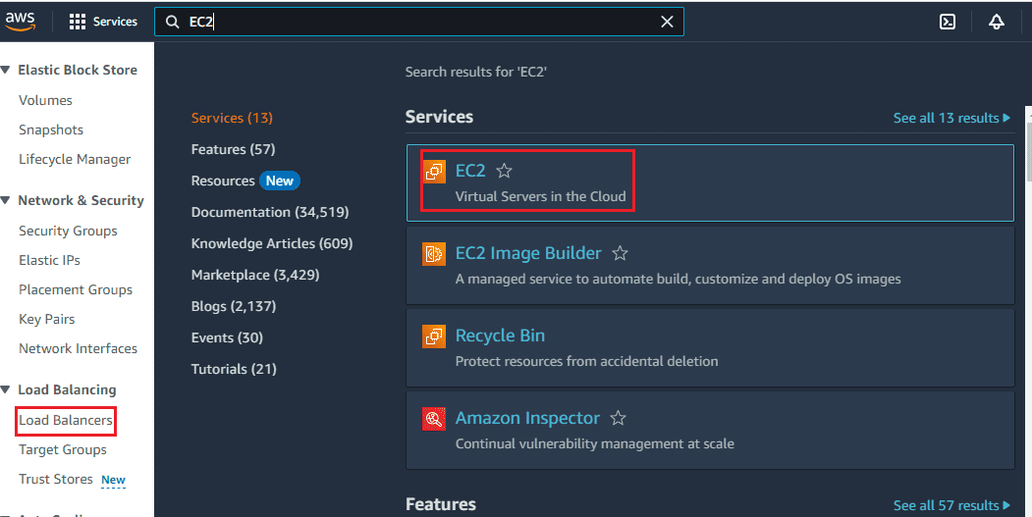

Step 2: In this step, first you can launch EC2 instance, Amazon EC2 allows you to create virtual machines, or instances, that run on the AWS Cloud.

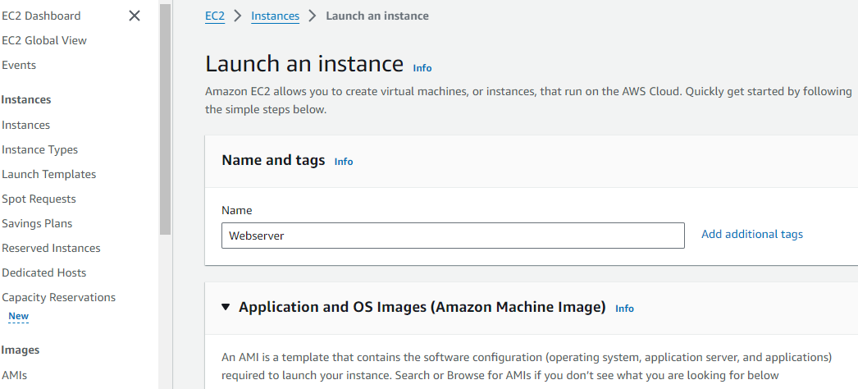

Application and OS Images, An AMI is a template that contains the software configuration (operating system, application server, and applications) required to launch your instance.

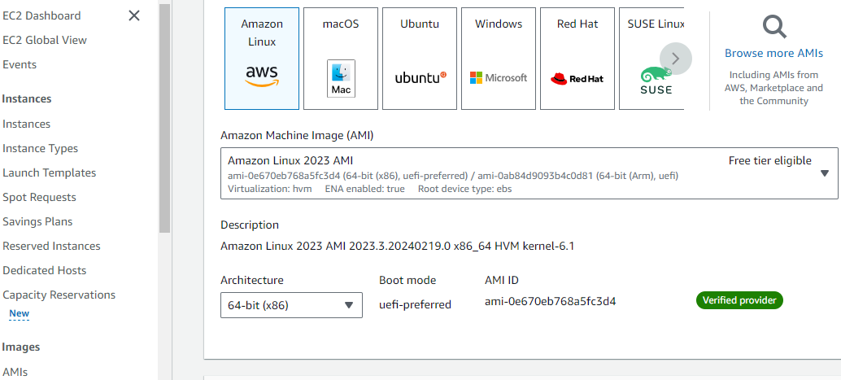

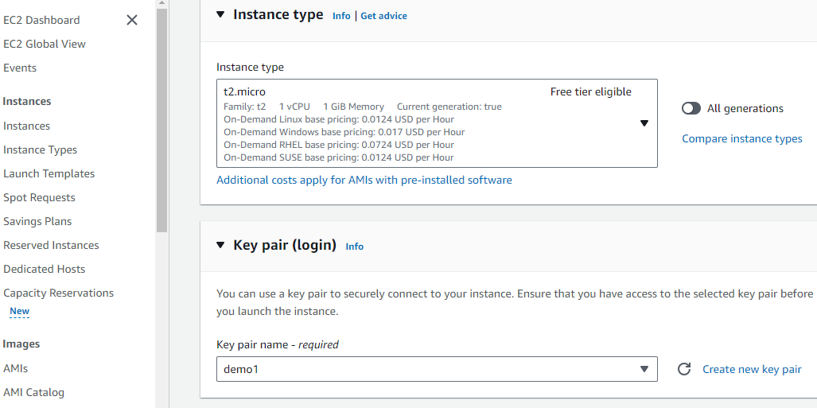

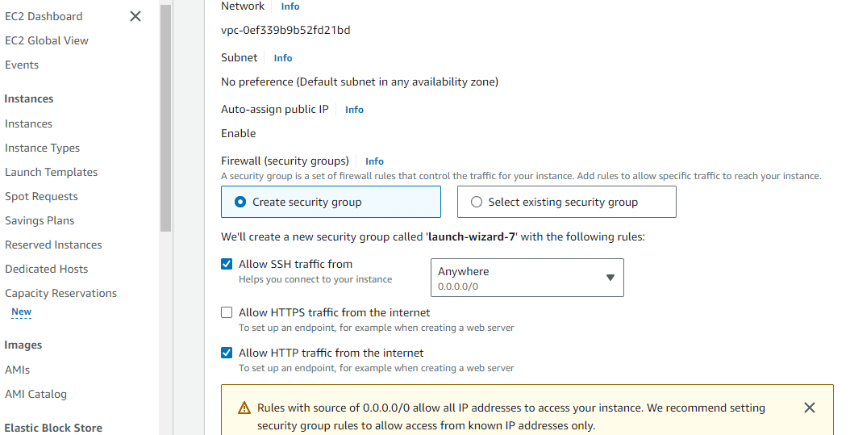

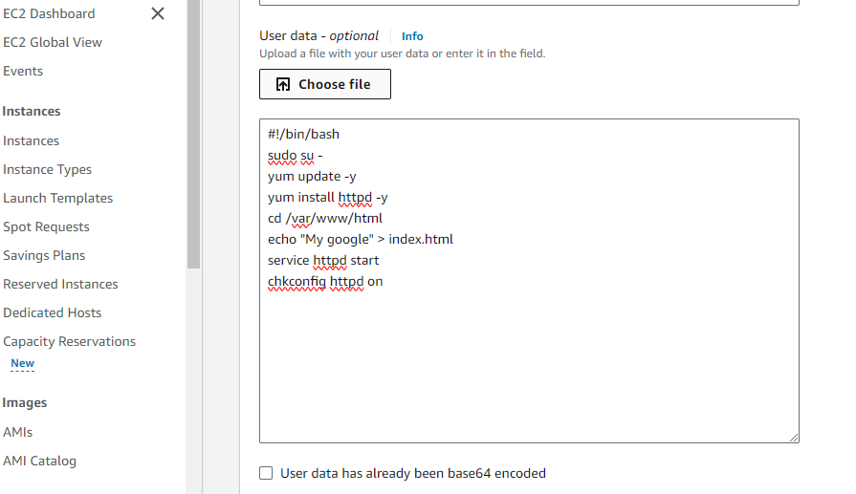

After enter the all details , the EC2 instance created succesfully as shown below,

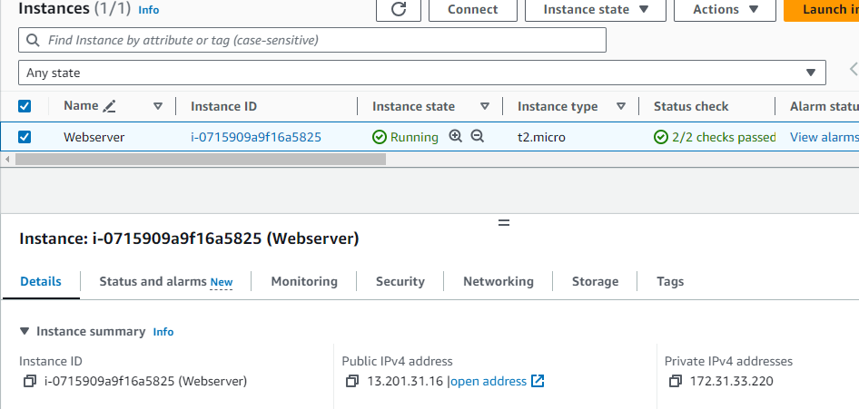

Step 3: Choose a load balancer type

Elastic Load Balancing supports different types of load balancers. In this step, we are going to create Application Load balancer, click on create an Application load balancer, and enter the basic configuration of application load balancer.

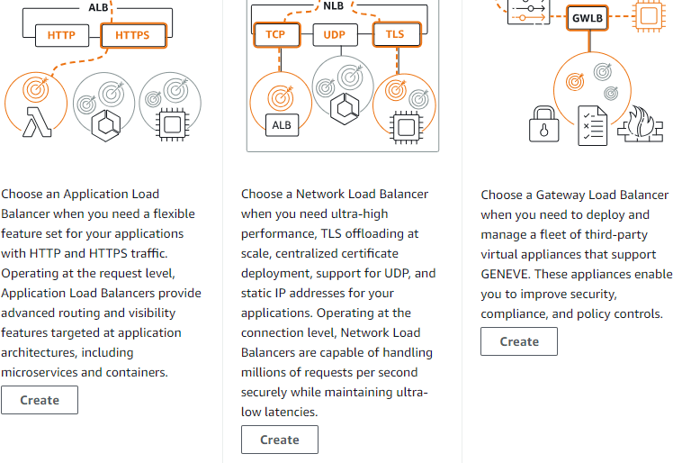

Step 4:Configure your load balancer

In this step to create an Application Load Balancer, you can provide basic configuration information for your load balancer, such as a name, scheme, and IP address type. Then, you provide information about your network, and one or more listeners. A listener is a process that checks for connection requests. It is configured with a protocol and a port for connections from clients to the load balancer.

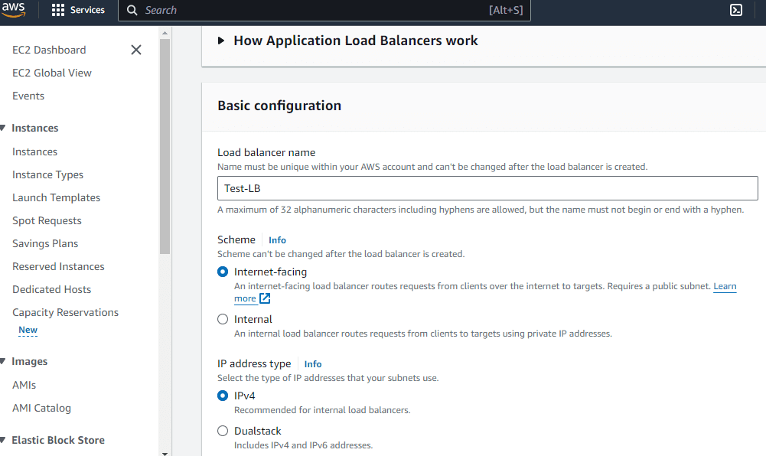

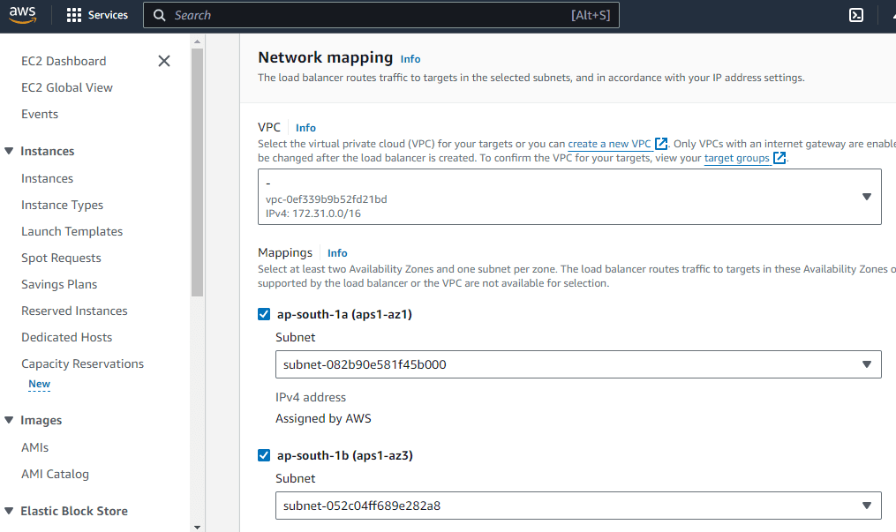

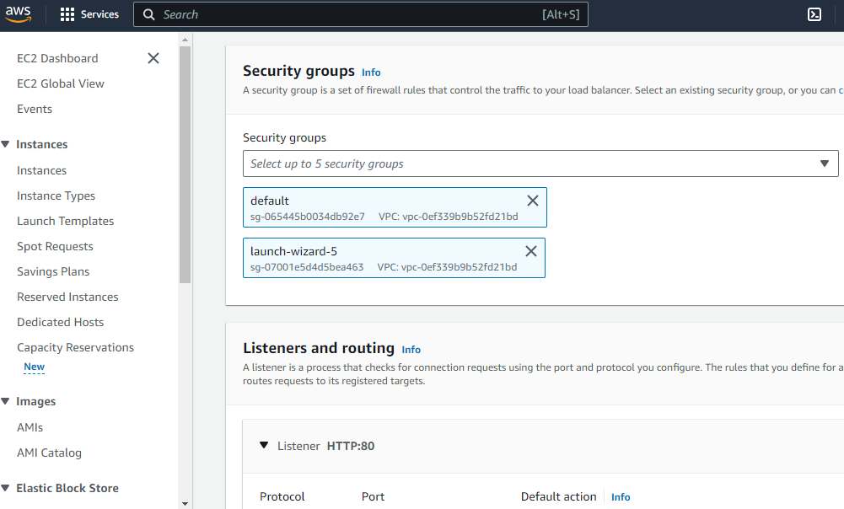

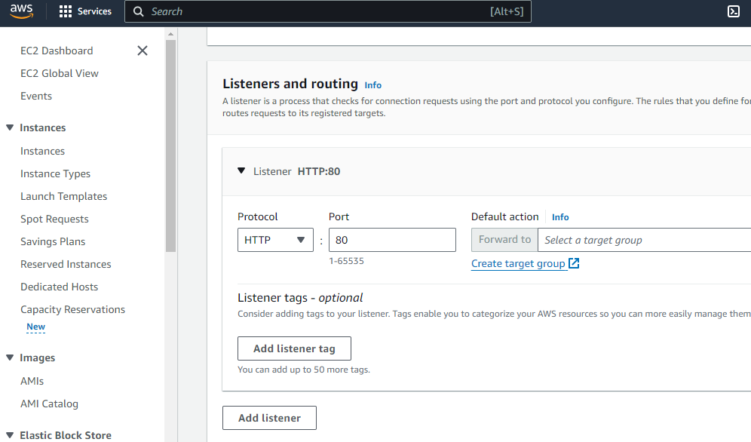

Step 5: Configure your target group

you can create a target group, which is used in request routing. The default rule for your listener routes requests to the registered targets in this target group. The load balancer checks the health of targets in this target group using the health check settings defined for the target group.

Choose Create target group.

Under Basic configuration, keep the Target type as instance.

For Target group name, enter a name for the new target group.

Keep the default protocol (HTTP) and port (80).

Select the VPC containing your instances. Keep the protocol version as HTTP1.

For Health checks, keep the default settings.

Choose Next.

On the Register targets page, complete the following steps. This is an optional
step for creating the load balancer. However, you must register this target if you want to test your load balancer and ensure that it is routing traffic to this target.

For Available instances, select one or more instances.

Choose Create target group.

Successfully created My-target-group.

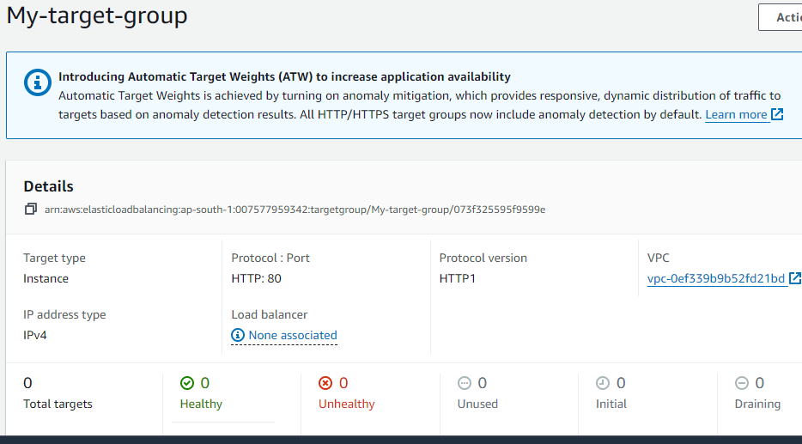

Step 6:Test your load balancer

After you are notified that your load balancer was created successfully shows below.

Select the newly created load balancer.

Choose Description and copy the DNS name of the load balancer (for example,Test-LB-504127462.ap-south-1.elb.amazonaws.com). Paste the DNS name into the address field of an internet-connected web browser. If everything is working, the browser displays the default page of your server.

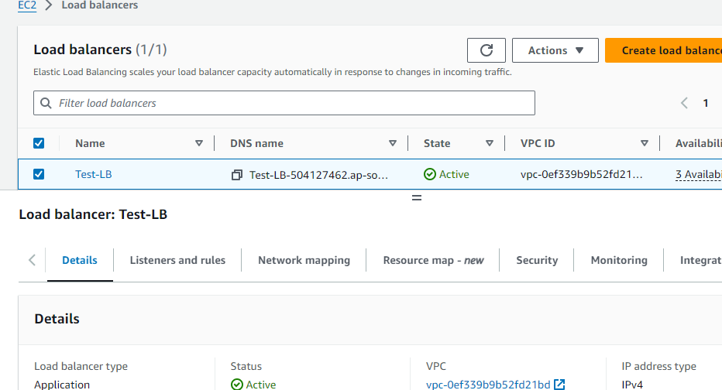

Step 7: Delete your load balancer

you are billed for each hour or partial hour that you keep it running. When you no longer need a load balancer, you can delete it. As soon as the load balancer is deleted, you stop incurring charges for it. Note that deleting a load balancer does not affect the targets registered with the load balancer. For example, your EC2 instances continue to run after deleting the load balancer created in this guide.

To delete your load balancer

Open the Amazon EC2 console at https://console.aws.amazon.com/ec2/

In the navigation pane, under Load Balancing, choose Load Balancers.

Select the checkbox for the load balancer, choose Actions, then choose Delete.

When prompted for confirmation, choose Yes, Delete.

AWS NETWORK LOAD BALANCER :

The Amazon Web Services (AWS) is provided Network Load Balancer (NLB) is a highly versatile and proficient load balancing arrangement designed to distribute incoming network traffic across various targets, for example, Amazon EC2 instances, containers, and IP addresses, inside the AWS environment. Working at the organization layer (Layer 4) of the OSI model, NLB insightfully routes traffic in based on IP protocol data, giving super low idleness and high throughput for requesting workloads.

Step-By-Step Process to create AWS Network Load Balancer

Step 1: Create Load Balancer

Now Go to AWS Management console and search for AWS Load Balancer and choose create load balancer.

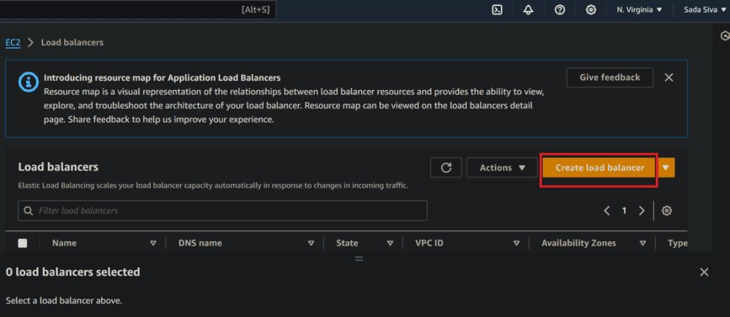

We need to create a network load balancer, so choose on Network Load Balancer.

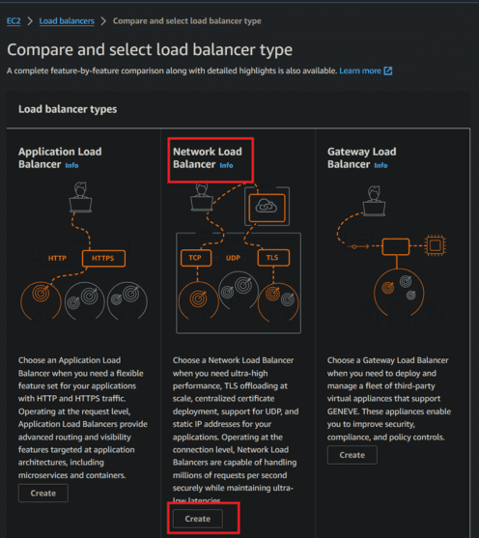

Step 2: Create Network Load Balancer

The Network Load Balancer distributes incoming TCP and UDP traffic across multiple targets such as Amazon EC2 instances, microservices, and containers. When the load balancer receives a connection request, it selects a target based on the protocol and port that are specified in the listener configuration, and the routing rule specified as the default action.

Now give name to Load balancer, Name must be unique within your AWS account and can't be changed after the load balancer is created.

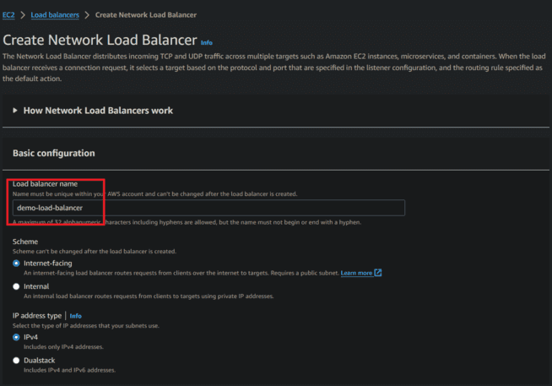

Step 3: Network Mapping

The load balancer routes traffic to targets in the selected subnets, and in accordance with your IP address settings.

Mappings: Select at least one Availability Zone and one subnet for each zone. We recommend selecting at least two Availability Zones. The load balancer will route traffic only to targets in the selected Availability Zones. Zones that are not supported by the load balancer or VPC can't be selected. Subnets can be added, but not removed, once a load balancer is created.

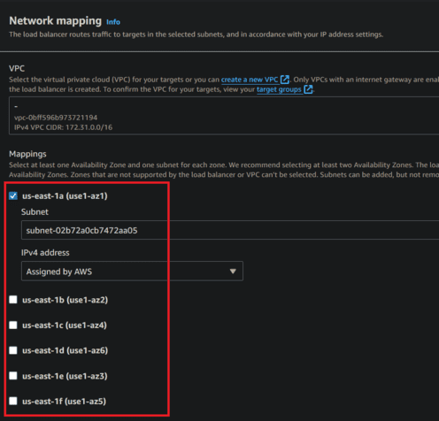

Step 4: Security Groups

A security group is a set of firewall rules that control the traffic to your load balancer. Select an existing security group, or you can create a new security group.

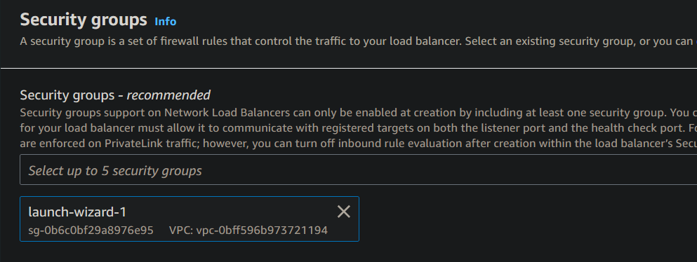

Step 5: Creating Target Groups

Our load balancer routes requests to the targets in a target group and performs health checks on the targets. So we need to create a target groups

Now specify target group details i.e., choose instance or IP address etc and specify target group name

Choose protocol port like http, httpd, tcp or any traffic.

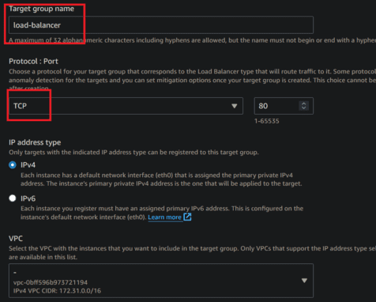

Health checks

The associated load balancer periodically sends requests, per the settings below, to the registered targets to test their status.

Now click on next and choose create target group.

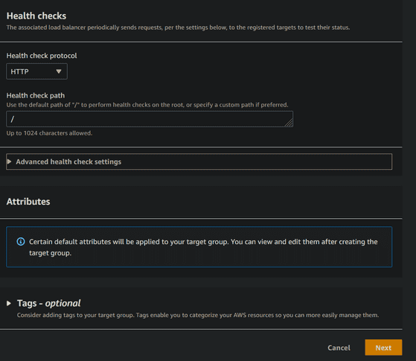

Step 6: Listeners And Routing

A listener is a process that checks for connection requests using the port and protocol you configure. The rules that you define for a listener determine how the load balancer routes requests to its registered targets.

Select created target group its shown in drop down menu.

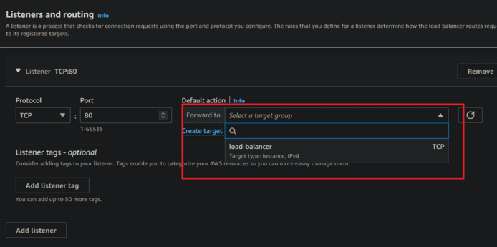

Now review and click on create load balancer.

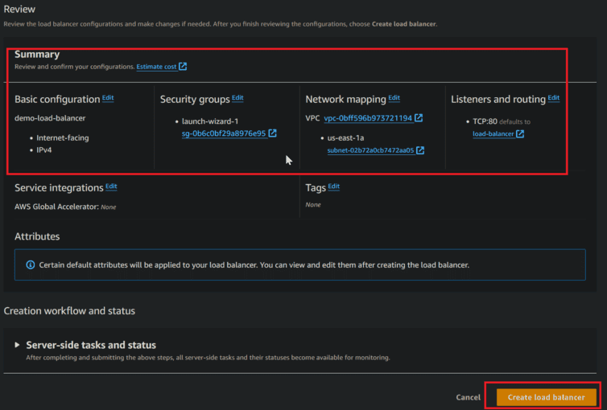

Here in below figures we can see that created load balancer.

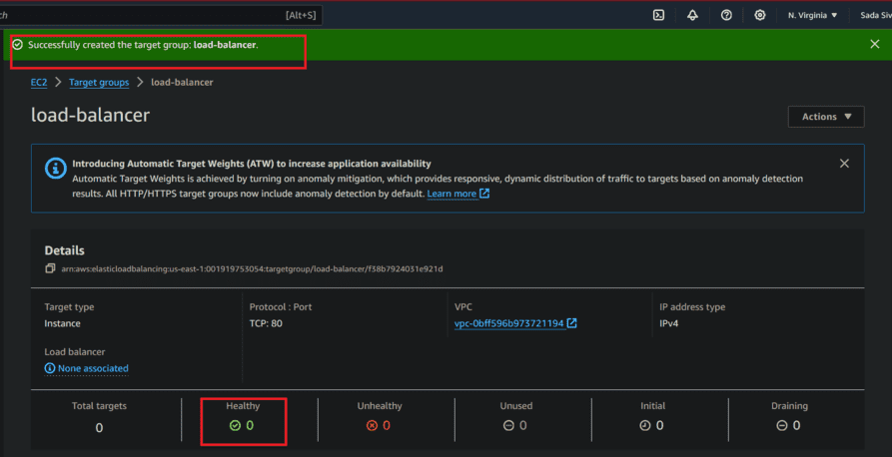

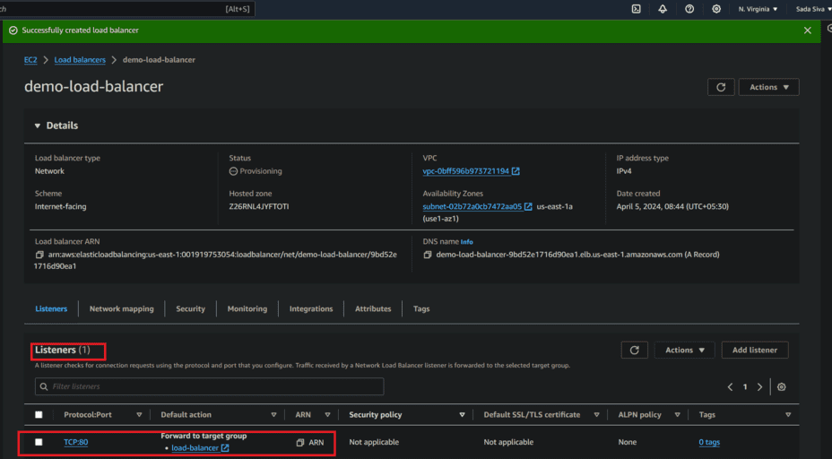

Step-By-Step Process to Delete the Network Load Balancer

Step 1: Navigate to the EC2 Dashboard.

Step 2: Under "Load Balancing," select "Load Balancers". Choose NLB you want to delete from the list of load balancers.

Step 3: Click the "Actions" dropdown.

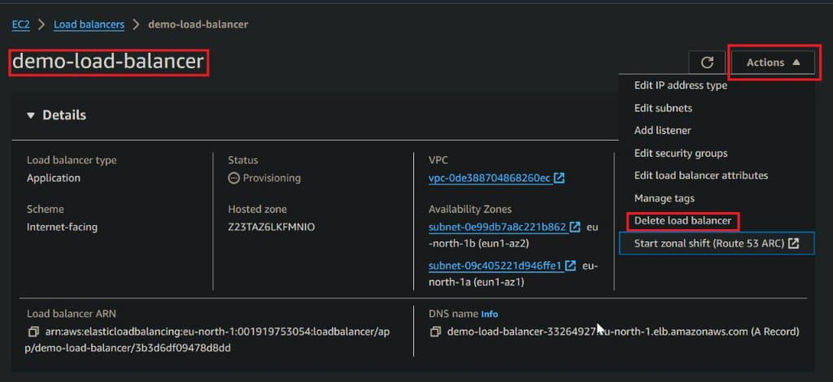

Step 4: Choose "Delete" from the dropdown menu.

Step 5: Confirm the deletion when prompted.

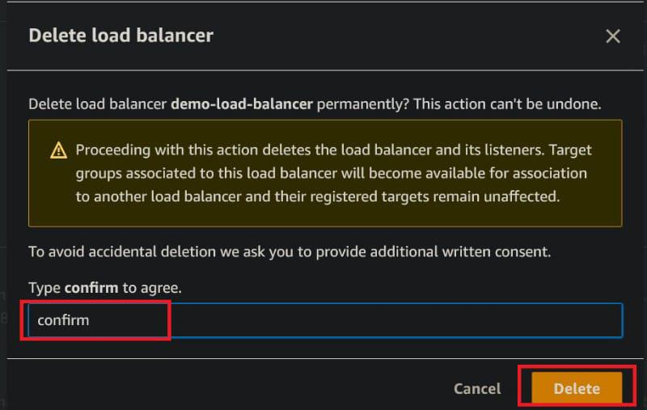

Here in below figure we can see that successfully deletion of Network load balancer

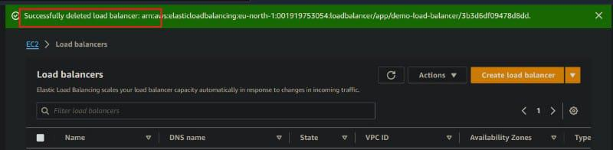

IP Address Types

IPv4: Clients use only IPv4 addresses (e.g., 192.0.2.1) to connect. It supports TCP, UDP, TCP_UDP, and TLS connections for both internet-facing and internal load balancers.

Dualstack: Clients can connect using either IPv4 or IPv6 addresses (e.g., 2001:0db8:85a3::8a2e:0370:7334). This option supports TCP and TLS connections.

Connection Idle Timeout

The load balancer tracks the state of each connection. If no data is sent through a connection for longer than the idle timeout, the connection is considered inactive.

For TCP connections, the default timeout is 350 seconds, and you can set it between 60 and 6000 seconds. TCP keepalive packets can reset the idle timeout, but cannot carry any data.

For TLS connections, keepalive packets are sent by the load balancer every 20 seconds on both front-end and back-end connections.

UDP connections don’t have persistent connections, but the load balancer keeps track of each flow based on IP addresses and ports. The idle timeout for UDP is fixed at 120 seconds.

EC2 instances must respond to new requests within 30 seconds to ensure a return path is established.

